Method to print(play) the playlist

public void printlist(Node node) {  
 Node last = null;  
 while (node != null) {  
 System.*out*.print(node.data + "-->");  
 last = node;  
 node = node.next;  
 }  
 System.*out*.println();  
}

The program will ask the user if they would like to play the playlist with repeat on or off.

If the user selects with repeat off then the playlist will only be played once in the forward direction

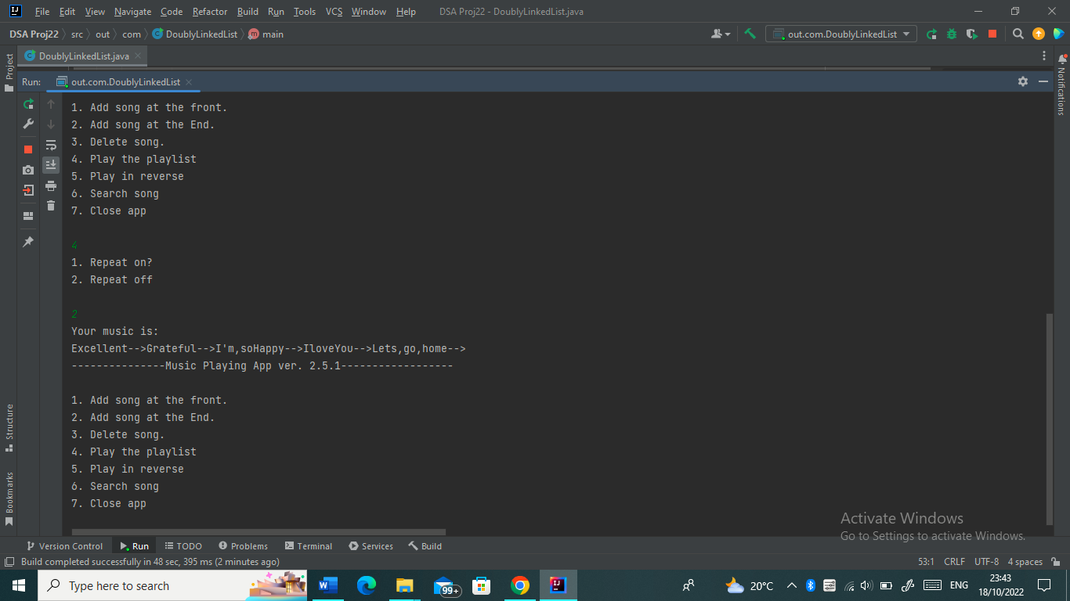

The program also allows the user to play back the playlist

public void printReverse(Node head_ref) {  
 Node tail = head_ref;  
 while (tail.next != null)  
 {  
 tail = tail.next;  
 }  
  
 while (tail != head_ref)  
 {  
 System.*out*.print( tail.data + "--> ");  
 tail = tail.prev;  
 }  
 System.*out*.println( tail.data );  
}

This function reverses the playing order of the playlist. The last song will be played first and the first song (at index 0) will be played last.

